# **Assignment 04**

Q1.

1- Obj++

2- Obj + 20

3- obj3 =obj1*obj2

4- if ( obj1< obj2)

5- if (obj1 == Obj2)

6- if (( Obj1*Obj2) > (Obj2/Obj3))

Q2. Why do we need friend functions, static functions and virtual functions?

**Friend Function**: A friend function can access the protected and private members of a class. These functions are defined outside the class and not inside. Friend functions are declared inside the class so the class can recognize them as “friend” and hence allow the friend function to access or modify its private and protected data members.

Coding example:

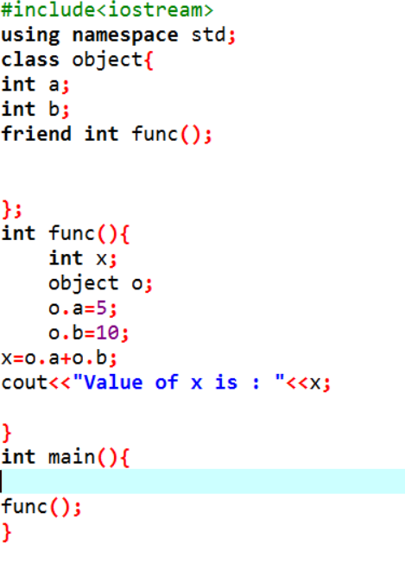

**Static Functions**: Static functions are needed to access the static data member declared inside the class and these functions can not access non-static data members. While other functions require an object for a class to be declared in main, the static functions can be called without an object declaration.

Coding example:

**Virtual Functions**: Virtual Functions are helpful in scenarios where functions are overridden(same function name and parameters)during inheritance or in different non-inherited classes. With a virtual function, the compiler knows that which correct overridden function it has to call. The compiler by default does early/compile-time binding while virtual functions allow late/runtime binding.

Coding Example:

